EXPT NO: 6 | IMPLEMENTATION OF LSTM FOR SENTIMENT ANALYSIS
DATE: 28/9/2026 | IMPLEMENTATION OF LSTM FOR SENTIMENT ANALYSIS

PRE-LAB QUESTIONS (PROVIDE BRIEF ANSWERS TO THE FOLLOWING QUESTIONS)

- What is the purpose of Long Short-Term Memory (LSTM) networks in NLP?
LSTM stands for Long Short-Term Memory. It is used to process text sequences and remember important information for a long time. It helps understand the relationship between words in a sentence.
Applications: Sentiment analysis, text generation, and language translation.
- Why is LSTM preferred over a Simple RNN for processing long text sequences?
LSTM can remember information for a longer time than a Simple RNN. Simple RNN may forget earlier information in long sentences due to the vanishing gradient problem. LSTM uses gates to control and store important information.
- What is sentiment analysis? Give two real-world applications.
Sentiment analysis is the process of finding the emotion or opinion in a text. It usually classifies text as positive, negative, or neutral.
Applications:
Analyzing product reviews.
Analyzing social media comments.
- Explain the role of tokenization and padding in text preprocessing.
Tokenization divides a sentence into smaller parts called tokens.
Example:
I love AI → I, love, AI
Padding adds extra values, usually zeros, to make all sentences have the same length.

- What is word embedding? Why is it useful for sentiment analysis?
Word embedding converts words into numerical vectors that represent their meaning.
For example, good, great, and excellent have similar meanings and can have similar vector representations.
It is useful in sentiment analysis because it helps the model understand the meaning of words and identify whether a sentence is positive or negative.

AIM
To implement a Long Short-Term Memory (LSTM) network for sentiment analysis by performing text preprocessing, tokenization, sequence generation, and embedding using NLP libraries, and classify text into sentiment categories.

SOFTWARE REQUIREMENTS
- Python
- TensorFlow / Keras
- Google Colab
- GitHub
- NumPy
- Pandas
- Matplotlib
- NLP libraries – NLTK / spaCy
- Scikit-learn

OBJECTIVES
Students will be able to:
- Understand the architecture and working of LSTM networks.
- Perform text preprocessing techniques for sentiment analysis.
- Tokenize and convert textual data into numerical sequences.
- Generate word embeddings for textual data.
- Build and train an LSTM model for sentiment classification.
- Evaluate the performance of the trained LSTM model.
- Analyze the effect of preprocessing and embedding on sentiment classification.

PROCEDURE
PART A: DATASET PREPARATION AND TEXT PREPROCESSING
- Perform the following tasks:
- Load a sentiment analysis dataset such as the IMDB Movie Reviews dataset.
- Explore the dataset and examine sample positive and negative reviews.
- Check the number of samples and sentiment class distribution.
- Perform text preprocessing using NLP libraries.
- Convert text to lowercase.
- Remove unnecessary punctuation and special characters.
- Remove stop words, if required.
- Tokenize the reviews into words/tokens.
- Convert the tokens into numerical sequences using a tokenizer.
- Build a vocabulary from the training reviews.
- Apply sequence padding to obtain equal-length input sequences.
- Encode sentiment labels into numerical form.
- Split the prepared dataset into training and testing/validation datasets.

CODE:
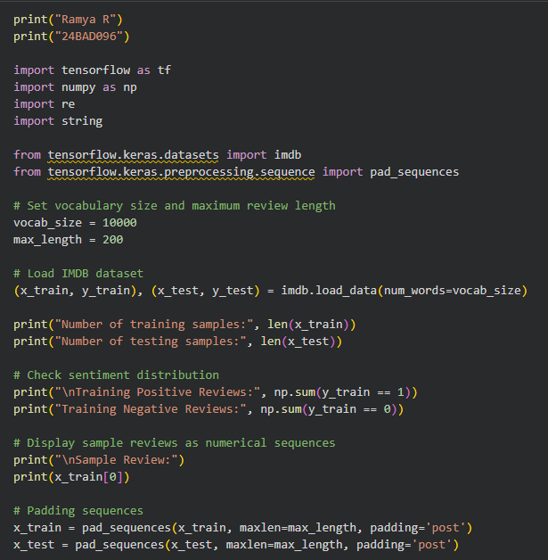
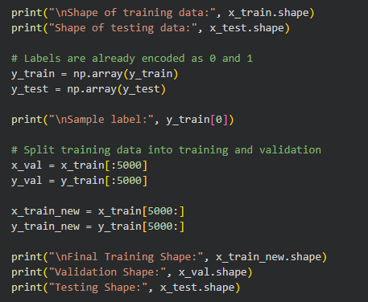
OUTPUT:
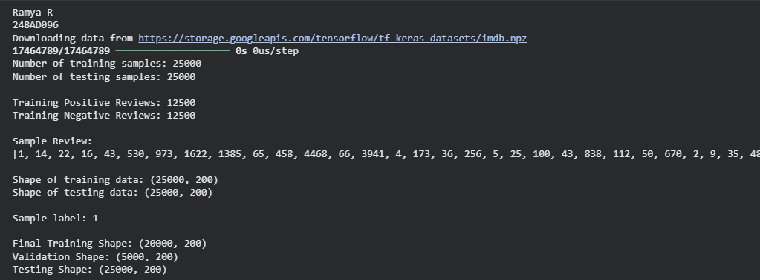

PART B: EMBEDDING GENERATION
Perform the following tasks:
- Generate numerical representations of the pre-processed text.
- Create an Embedding layer using Keras/TensorFlow.
- Define the vocabulary size and embedding dimension.
- Convert tokenized sequences into dense vector representations.
- Display the shape of the generated embedding representation.
- Analyze how words are represented in the embedding space.

CODE:
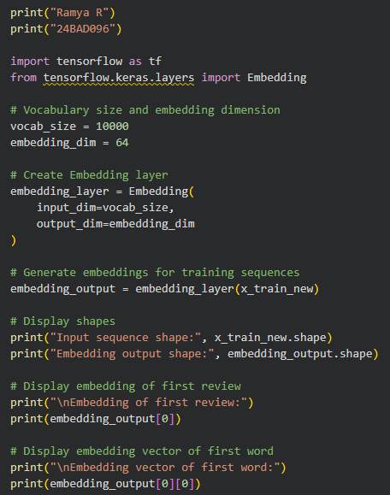
OUTPUT:
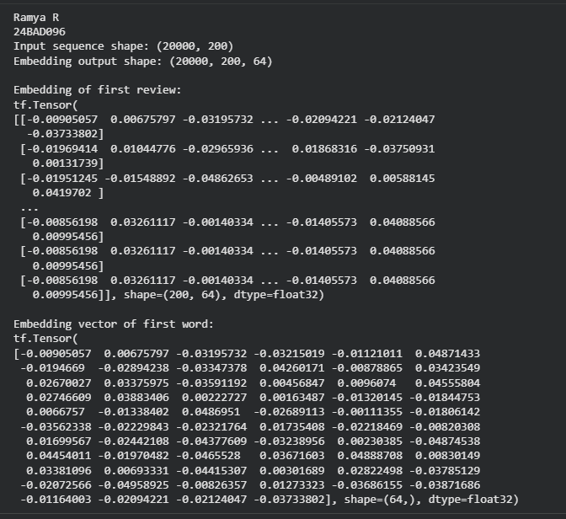
PART C: IMPLEMENTING THE LSTM MODEL
Perform the following tasks:
- Create an input layer for the padded text sequences.
- Add an Embedding layer to generate dense word representations.
- Add an LSTM layer to learn sequential dependencies in the reviews.
- Add a Dense output layer with an appropriate activation function for sentiment classification.
- Compile the model using:
  - Appropriate optimizer
  - Binary cross-entropy loss
  - Accuracy as the evaluation metric
- Display the model architecture and summary.

CODE:
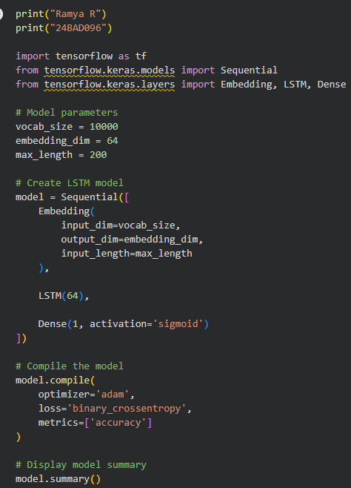
OUTPUT:
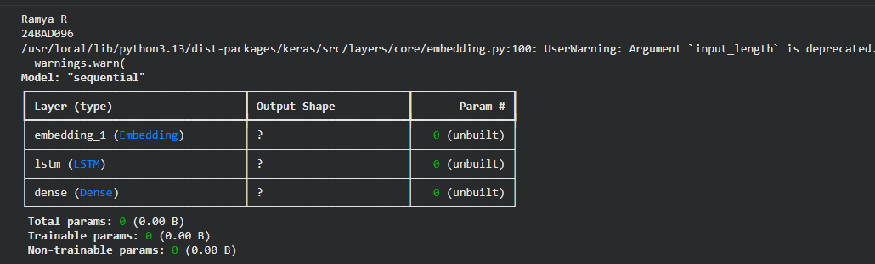
PART D: MODEL TRAINING AND SENTIMENT PREDICTION
Perform the following tasks:
- Train the LSTM model using the prepared training dataset.
- Validate the model using the validation dataset.
- Record:
  - Training accuracy
  - Validation accuracy
  - Training loss
  - Validation loss
- Visualize:
  - Accuracy vs. Epoch
  - Loss vs. Epoch
- Evaluate the trained model using the test dataset.
- Predict the sentiment of sample reviews.
- Compare the predicted sentiment with the actual sentiment.
- Calculate appropriate evaluation metrics such as:
  - Accuracy
  - Precision
  - Recall
  - F1-score
  - Confusion matrix
CODE:
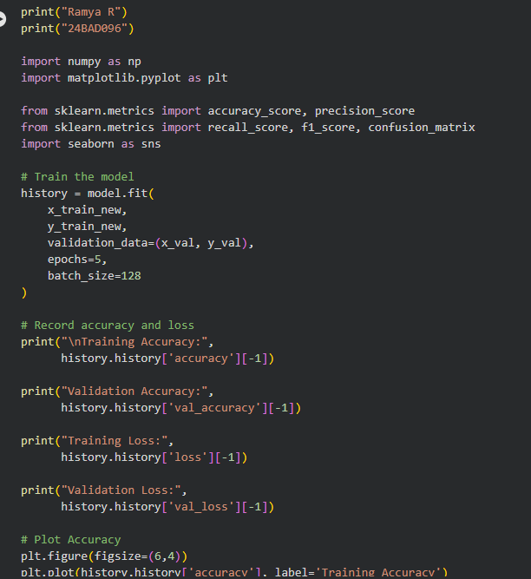

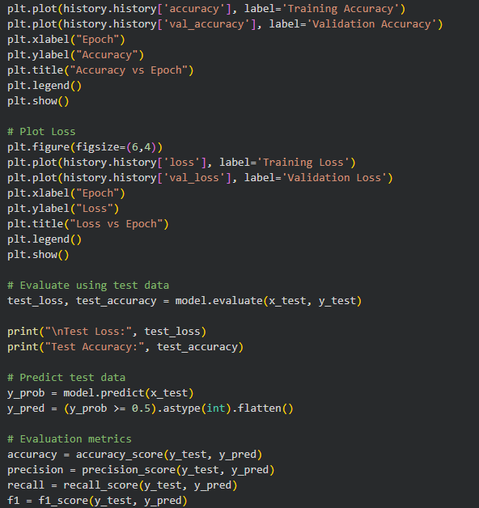

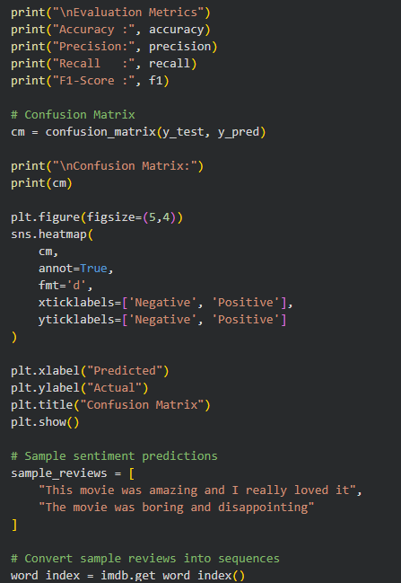

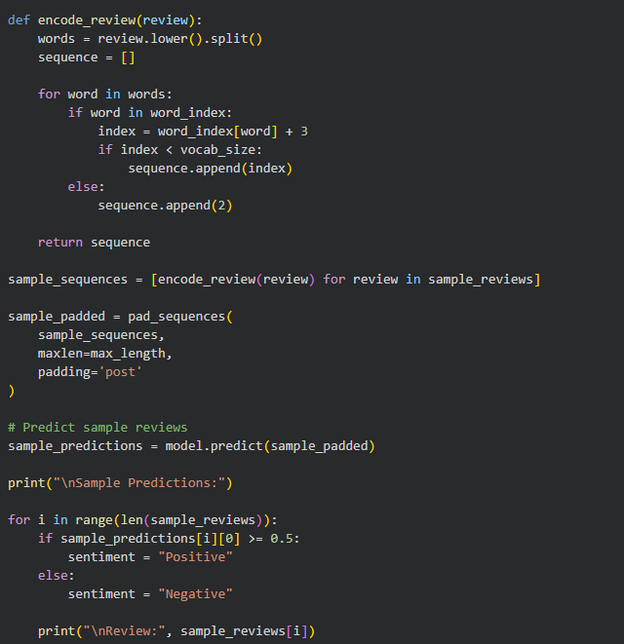
OUTPUT:
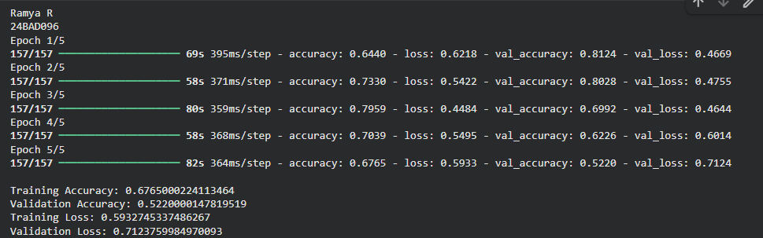
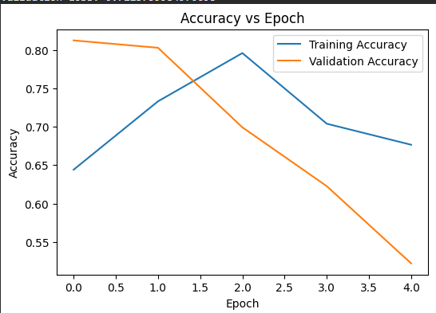
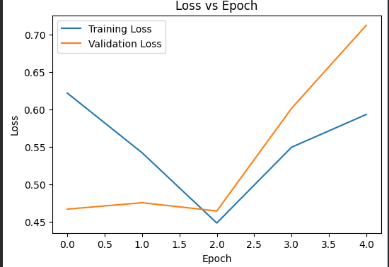
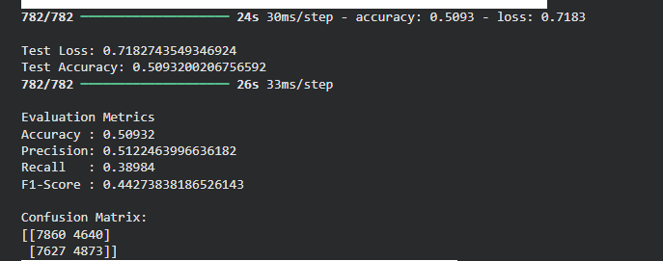
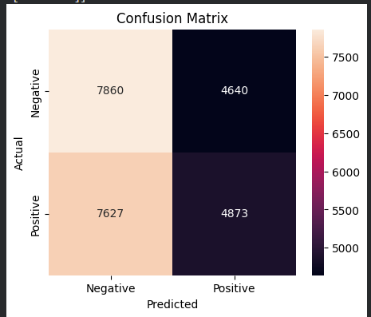
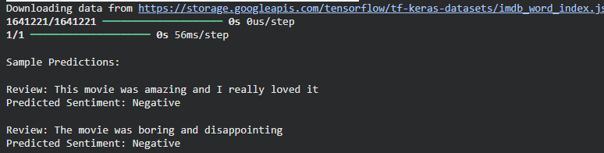

EXPECTED OUTCOME
Students will understand how LSTM networks learn sequential information from textual data and apply them to sentiment classification. Students will learn to perform text preprocessing, tokenization, sequence padding, and embedding generation using NLP libraries. They will build and train an LSTM model and evaluate its ability to classify reviews into positive and negative sentiments.

POST-LAB QUESTIONS (PROVIDE BRIEF ANSWERS TO THE FOLLOWING QUESTIONS)

- What is the role of the memory cell in an LSTM?
- The memory cell stores important information.
- It carries information from previous time steps.
- It helps the model remember long-term dependencies.
- Gates control what information is stored or removed.

2.How does an LSTM overcome the vanishing gradient problem of a Simple RNN?
- LSTM uses a special cell state to carry information.
- It uses forget, input, and output gates.
- These gates control the flow of information.
- This helps preserve gradients over long sequences.

3.What is the purpose of the Embedding layer in the sentiment analysis model?
- It converts words into numerical vectors.
- Similar words can have similar vector representations.
- It reduces the complexity of word representation.
- These vectors are given as input to the LSTM.

4.How does padding affect the input to an LSTM network?
- Padding makes all sequences the same length.
- Extra values, usually zeros, are added to shorter sequences.
- It allows sequences to be processed in batches.
- The LSTM can then handle inputs of uniform size.

5.What happens when the LSTM model is trained for too many epochs?
- The model may learn the training data too closely.
- This is called overfitting.
- Training accuracy may continue to increase.
- Validation accuracy may decrease.

6.Why are precision, recall, and F1-score useful in addition to accuracy?
- Accuracy alone may not show complete performance.
- Precision measures correct positive predictions.
- Recall measures how many actual positives are detected.
- F1-score combines precision and recall.

7.Give one limitation of using LSTM for sentiment analysis.
- LSTM models can take a long time to train.
- They require more computational resources.
- They can be complex compared with simple models.
- They may also overfit when trained too much.

SUGGESTIONS FOR DATASETS
- IMDB Movie Reviews – https://ai.stanford.edu/~amaas/data/sentiment/
- SST-2 (Stanford Sentiment Treebank) – https://huggingface.co/datasets/stanfordnlp/sst2
- Twitter Sentiment Analysis – https://www.kaggle.com/c/twitter-sentiment-analysis
- Stanford Sentiment Treebank (SST) – https://huggingface.co/datasets/stanfordnlp/sst
- Amazon Product Reviews – https://huggingface.co/datasets/amazon_polarity
- Yelp Polarity Reviews – https://huggingface.co/datasets/fancyzhx/yelp_polarity

ASSESSMENT
Description | Max Marks | Marks Awarded
Pre Lab Exercise | 5
In Lab Exercise | 10
Post Lab Exercise | 5
Viva | 10
Total | 30
Faculty Signature

